am Saturday

10.00 Bells – Cradley ringers – Sue Hughes on Organ
10.15 Terce Office – sung by Cradley Church Choir
10.30 James & Hannah Williamson
10.45 Francesca Blin
11.00 Ian Gifford sings
11.00-1.00 Mozart rehearsal for newcomers at School
11.30 St James’ School choir
Noon Pedro’s drum & percussion workshop
Sext Office – sung by Cradley Church Choir
pm Ploughman’s lunches in Church – Bar Open
12.30 Sarah Herriot string quartet
12.30 Balloon Launch in Churchyard
1.00 Bruce Herriot sings (Doc slot)
1.30 Bishop’s School Choir
2.00 Pax Singers
2.30 Cradley School children, choir/orchestra
3.00 Cradley school governors, teachers & Friends
perform excerpts from ‘Oliver’ (unmissable!)
3.00 Registration & tea for all singers followed by full
Mozart Requiem rehearsal in school

Cream Teas in Church

4.00 Felicity Rogers
4.15 Frog Racing in Churchyard
4.30 Jimmy’s Band (Orchestra of St. James’ the Great)

Hot Dogs being served
5.00 The Robertson family
5.30 King’s School Worcester

6.00 Evensong – Sine Nomine
Pig Roast, & Veggie Special in churchyard
(continuing all evening)
6.00 Scottish Country Dancing outside with Bertie’s
bagpipes & Katie calling
7.00 Jazz pianist Mark D’Inverno
7.30 Mozart’s Requiem conducted by Stefan Scot
8.30 Tony & Mary McQueen sing folk songs
9.00 David Huke Trio play jazz
9.30 Greenwood Voices
10.00 The Remains, rock band
10.30 Les Darrall on guitar
11.00 Sing-Along - Sound of Music
directed by Roger Harington - nun better!

am Sunday

Soup Kitchen open for Night Watch
1.30 Reprise from Cradley Pantos past…….

Bar Closes
And Pantos to come ……………
2.30 Roger Gill & sons
3.00 A taste of pantos to come……..
3.15 The Full Rokirkski, jazz/accoustic band
3.45 Matins (Laudes & Prime) – Sine Nomine
4.30 Mike Vockins
5.00 Jamie McAleese
5.30 Martin McAleese
6.00 Roger & Virginia – songs from Tom Lehrer
6.30 Sam Ashton with Horatius
7.00 Katrina Turnbull – pop songs & Sanskrit chant
7.15 Bertie Aykroyd – Piping in the Day
7.30 Christians Together
8.00 Paul Roberts Organ and Piano
8.30 Mathon Church Singers
Marathon Breakfast served in Church
9.00 Arthur Bancroft on violin
9.30 The Full Rokirkski
10.00 Alan Robinson & Nick Gill - jazz
10.30 Bells – Cradley ringers. Bill Herring on Organ
11.00 Celebration Service with Jimmy’s Band
Noon The Grand Raffle Draw
Bar open for celebration drink and filled
Tortilla wraps available for light lunch
Sponsors
We would like to express our sincere thanks and appreciation to the following who have generously sponsored the set up costs of this event.

G. Beech, Decorator Beatties
Colwall Motor Services Evendine House
Hanley Interiors Heathfield Services
Keys of Malvern Laneys Antiques
Millbank Garages Mower Repair Services Netherley Shoot North Ledbury Hunt Ridgeway Joinery F. W. Spilsbury,
Tricia Fouque, Psychotherapy Geoffrey Vos
Vale Pianos of Pershore Vinesend Shoot
Mathon Cradley & Storridge Tennis Club

We are immensely grateful for the generous support, which has made this event possible from School Governors, Parents, Head Teacher Dawn Hyett and her staff, the parishioners of St. James’ the Great and members of the Village Hall Committee.
A big thank you to Holly Welford for her excellent logo which has been the basis of all our publicity material.

Special thanks to all those who are providing bell-ringing, music and entertainment (particularly our conductor Stefan Scot), sustenance, stewarding, stalls, car parking, decoration or any other support during the actual 26 hours.
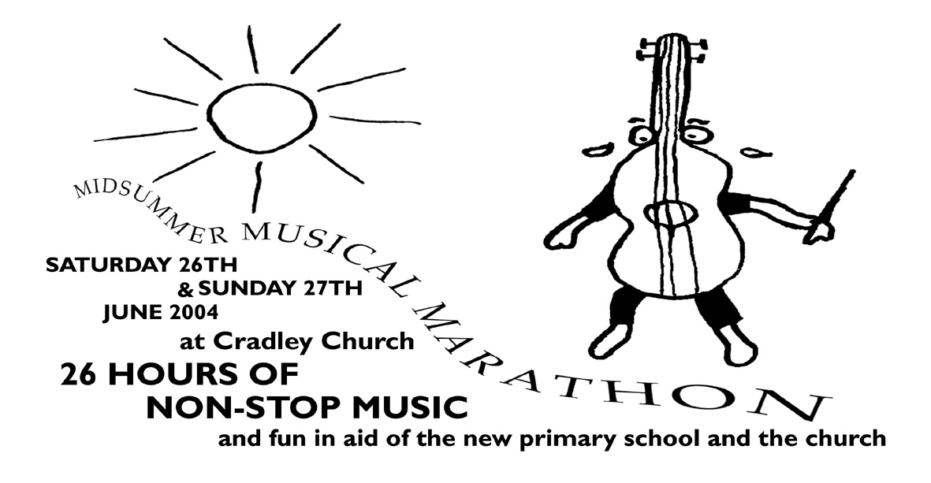

Saturday 26 June highlights
Cradley church, grounds and lane (10.30-6pm)
“Morning Dew”, Scottish Piper, Buskers
vintage stationary engines
Stalls, crafts + games galore, face painting,

Ploughman’s Lunches, Cream Teas
Evening - Pig Roast Hot Dogs and Veggie Special
Licensed Bar
Children’s drum workshop with Pedro
Balloon Launch - Frog Racing
Scottish Country Dancing to Pipes
Mozart’s Requiem from Scratch
(not too late to book in for Workshops)
Sing-along Sound of Music (in costume)

Sunday 27 June highlights
Marathon breakfast in church & Celebration Service

See inside for full 26 hour programme

