Some hidden Angels
Please do not touch the Angels. Show your completed sheet and get a treat!
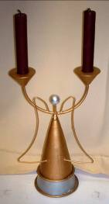  How many candles?  What colour are the candles?  Where did you find the Angel? | 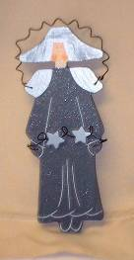  What is missing from her face?  How many stars is she holding?  Where did you find the Angel?
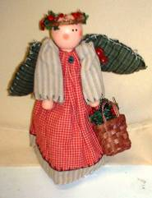  What is she carrying in her basket?  What colour is her dress?  Where did you find the Angel? | 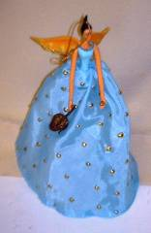  What are the spots made of?  Who does she look like?  Where did you find the Angel?
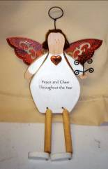  What is on the top of her wand?  Peace and ______ ?  Where did you find the Angel? | 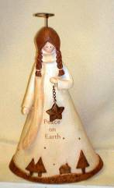  What type of hair style does this Angel have?  What is around the hem of her dress?  Where did you find the Angel?
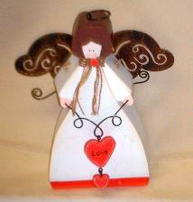  How many hearts on this Angel?  What is she made of?  Where did you find the Angel? | 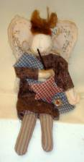  What has he caught on his fishing rod?  How many buttons can you see?  Where did you find the Angel?
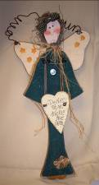  What is written on the heart?  How many stars are there on the wings?  Where did you find the Angel? | 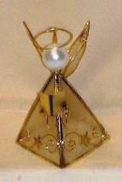  What shape is the Angel’s body?  What is she holding?  Where did you find the Angel?
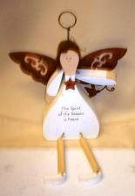  Complete “The spirit of the _____ is _____”  What is on her neck?  Where did you find the Angel? | 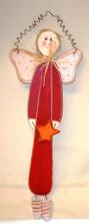  How many spots on his wings?  What is on his socks?  Where did you find the Angel?
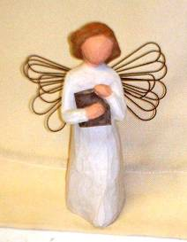  What is the Angel carrying?  Do you like this Angel?  Where did you find the Angel? | 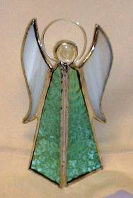  How many pieces of glass is this Angel made from?  What is the circle called that surrounds her head?  Where did you find the Angel?

What did you like best about all the Angels you have seen?

